SIMATS ENGINEERING
ASSESSMENT TOOL 1

COURSE NAME: Database Management Systems
COURSE CODE: CSA05

COURSE OUTCOME COVERED

CO1: Analyze DBMS architecture, different data models, schema types, and design ER/EER diagrams, relational schemas for case-based scenarios by identifying entities and relationships. (BL1, BL2)

Activity Tool : Short Answer Text(High)
Assessment Tool Weightage: 40%

 | QUESTIONS
Q. No | Question | Bloom's  Level
1 | Explain schema and instance with examples. Distinguish between logical schema, physical schema, and view schema. | BL1 –  Remember
2 | Identify the entities, attributes, and relationships for a Bank Management System and construct its ER diagram. | BL2 –  Understand
3 | Explain the Extended ER (EER) model. Describe the concepts of generalization, specialization, and aggregation. | BL2 –  Understand
4 | Design an EER diagram for a Hospital Management System incorporating inheritance and weak entities. | BL2 –  Understand
5 | Explain the role of a DBA (Database Administrator) and the responsibilities associated with the position. | BL1 –  Remember

- UPS product tracking system

Code of Conduct:

I Gunavathi. A (192511374) (Name / Reg No) certify that this submission is my original work and that I have adhered to the guidelines specified for this assessment. I understand that any violation of academic integrity rules will result in disciplinary action.

Gunavathi. A
Signature of the student:

1) Explain schema and instance with examples. Distinguish between logical schema, physical schema, and view schema.

1. Schema
A schema is the overall design or structure of a database. It defines tables, attributes, data types, and relationships.

Example of Schema
STUDENT(StudentID, Name, Department)
COURSE(CourseID, Title, Credits)
This structure remains relatively stable.

2. Instance
An instance is the actual data stored in the database at a particular moment.
Student id | Name | Department
101 | Bavani | cse
102 | hema | Bio
If a new student is added, the instance changes, but the schema remains the same.
Schema vs Instance
Schema | Instance
Database blueprint | Current data
Changes rarely | Changes frequently
Defined by DBA | Updated by the user
Eg: Table structure | Example: rows in the table

Difference between Logical, Physical, and View Schema

Feature | Logical Schema | Physical Schema | View Schema
Describes | Database structure | Storage implementation | User's view
Focus | Tables and relationships | Files, indexes, and blocks | Visible data
Level | Conceptual | Internal | External
Changes | Occasionally | May change for optimization | Depends on user needs
Eg | STUDENT table definition | B+ tree index on StudentID | Faculty view of students

2) Identify the entities, attributes, and relationships for aBank Management System and construct its ERdiagram.

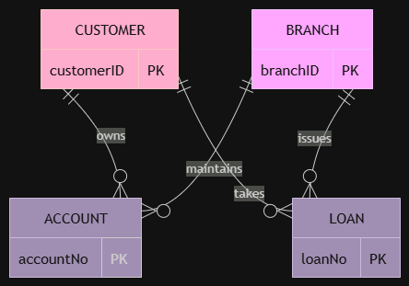

3) Explain the Extended ER (EER) model. Describe theconcepts of generalization, specialization, and aggregation.

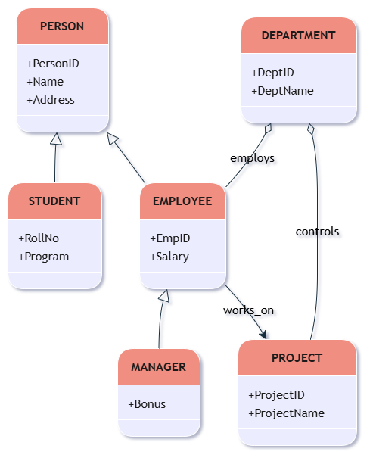

4) Design an EER diagram for a Hospital Management System incorporating inheritance and weak entities.

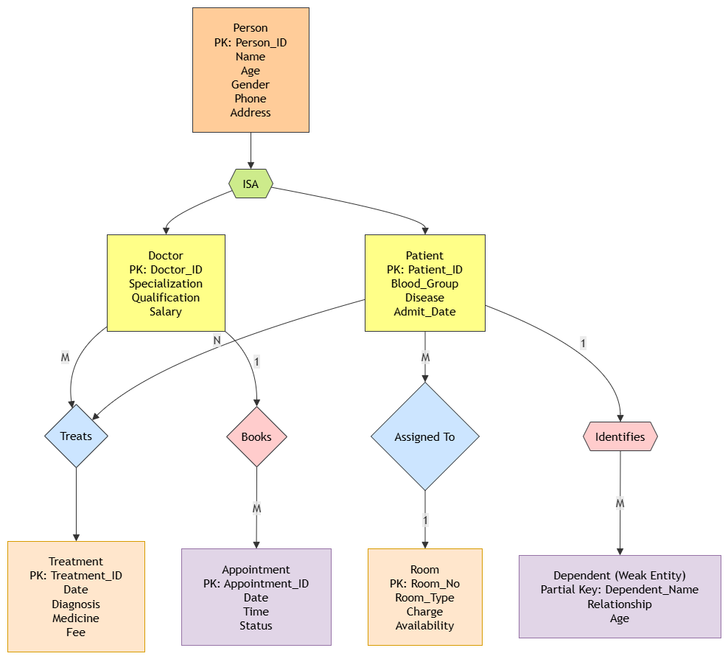

5) Explain the role of a DBA (Database Administrator) and the responsibilities associated with the position.

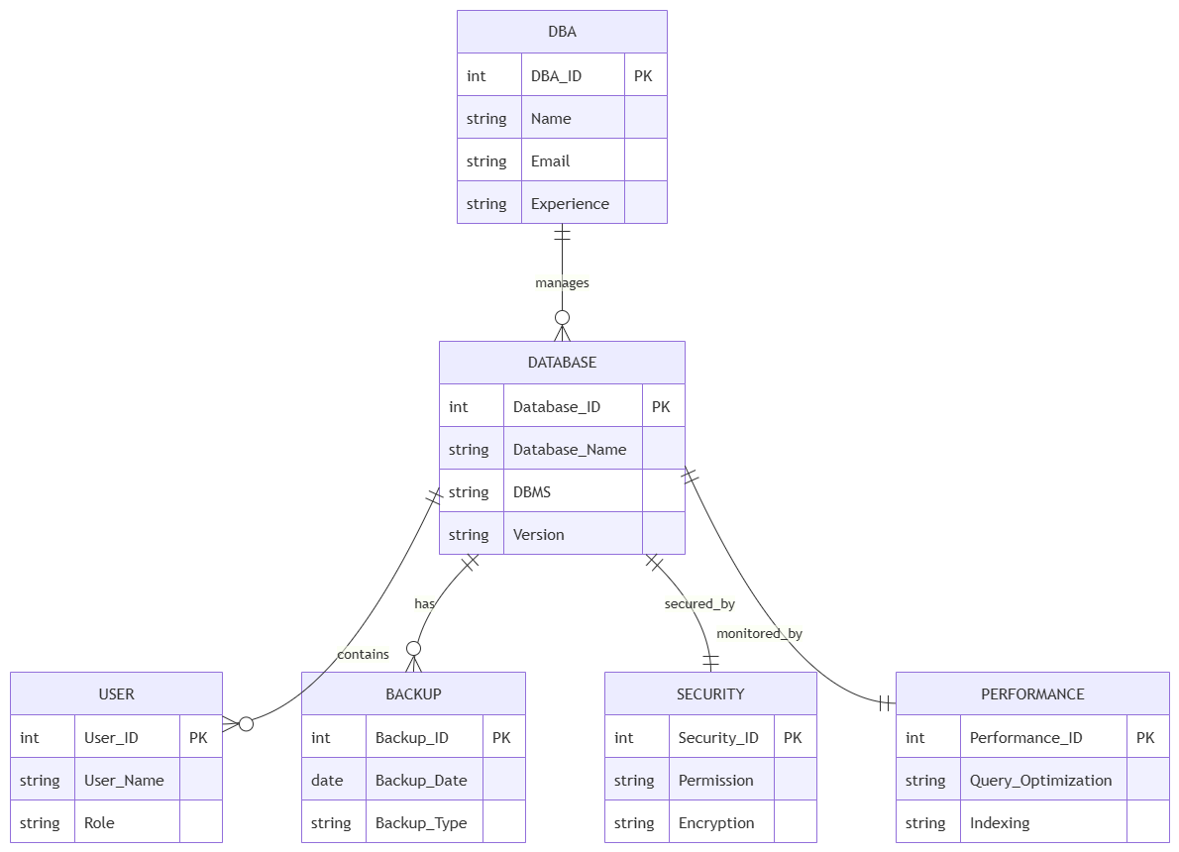

RUBRICS FOR CALCULATION:

Criteria | Weightag  e | Level 4 (Exemplary) | Level 3 (Proficient) | Level 2 (Developing) | Level 1 (Beginning)
Concept  Identification | 30% | Demonstrates clear and  complete  understanding of the concept | Good understanding with minor gaps | Basic understanding with some  misconception  s | Poor or incorrect  understandin g
Linkages | 25% | Completely correct answer with no errors | Mostly correct with minor errors | Partially correct  with noticeable errors | Incorrect or irrelevant answer
Organizatio n | 20% | Correctly applies concepts to solve  the  question/proble m | Applies concepts with minor mistakes | Limited or partially correct application | No or incorrect application
Integration of Literature | 15% | Covers all required parts of the question | Covers most parts with minor omissions | Covers only some parts | Incomplete or missing response
Clarity | 10% | Clear, concise, and well-  organized answer | Understandab  l  e with minor issues | Somewhat unclear or poorly structured | Difficult to  understand

